**Search the logo programming language online to discover more about it. Write a short description on the logo programming language in around 200 words.**

Logo is an educational programming language made by Wally Feurzeig, Seymour Papert and Cunthia Solomon in 1967.

It is a general-purpose language and is well known for its use of turtle graphics. Turtle graphics are commands which are used to move and draw vector graphics. The commands control a “turtle” which is used to draw on the screen. This allows students to easily visualise

Square.py

wheelSpokes.py

wheelSpokesWiggle.py

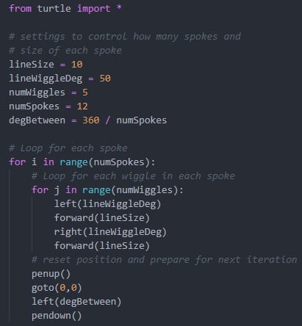

Activity 3

The code on the board makes 9 squares on the screen 40 degrees apart all connected by a line at 0,0.

Activity 4

Activity 5

1: 1

2: 9

3: 36

4: 9

Activity 6

10, 10